Dhruva Arun
06/26/2023 - 08/25/2023

UAS-Based Forest Inventory Development with Swarming Algorithms

Problem Description
After talking to Peter Root, a professional at Wildfire Robotics, I have found that wildfire suppression with water and other methods should only be performed when absolutely necessary to protect a community. Otherwise, it is beneficial to nature to allow the wildfires to naturally burn through the forest, producing the ideal environment for new forests to grow. Mr. Root explained that the best action that can be taken right now is working to generate an inventory of trees in forests across the globe (species, height, age, etc.), thus allowing experts to track the path a given wildfire will take and create controlled burns to protect communities. Multiple companies are working towards this goal right now with innovative solutions (Foresite).

Recent work done in this research paper made use of UAVs with SfM processing to develop point clouds of trees, allowing for a cheaper and functional alternative to ALS and TLS (Aerial and Terrestrial Lidar Sensing). The study asserted that flight patterns and camera angles significantly affect the precision and error of the measurements taken by the UAVs. The research paper tested the below flight patterns and camera angles:
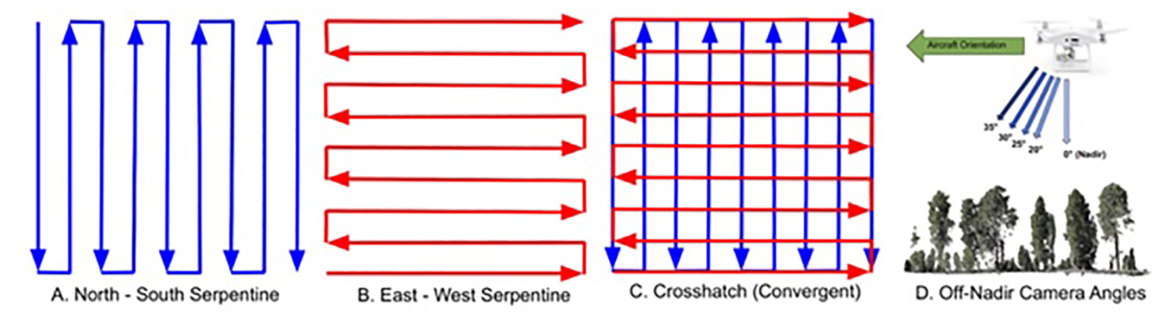
It finally concluded that the measurements “might see efficiency gains by flying entire stands with serpentine patterns and then sample portions of a stand with a crosshatch pattern … Work is needed to understand what proportion of a stand (uniform forest community) needs to be sampled with the crosshatch pattern to ensure enough DBH values are extracted to impute the missing DBH values.”
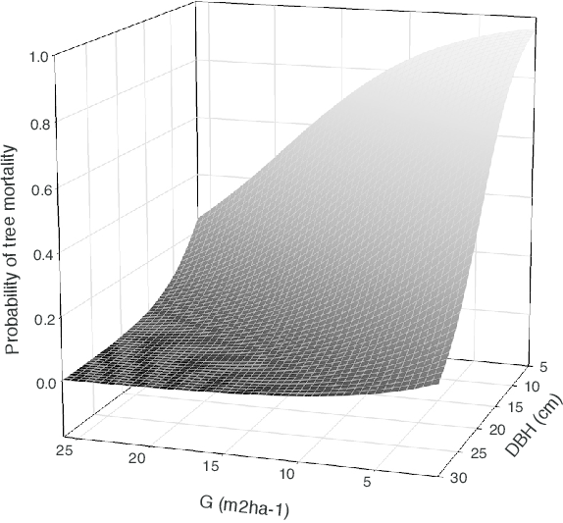
Currently, the research paper fills in the missing DBH values (about 80% of the DBH values are missing) with a prediction model that depends on the tree’s extracted height. However, the predictions do not provide the accuracy required to precisely track wildfires. Knowing the DBH values of individual trees is extremely important as they provide additional information like tree mortality that is essential in forest fire tracking. The importance of DBH can be seen in the graphic to the right:

I am working on a swarming algorithm to, given the positions and heights of the trees (which IS accurately and consistently measured for every tree), measure tree DBH values while prioritizing shorter trees and areas with high densities of missing DBH values. The swarming algorithm will take place after a set of SfM drones sweep the entire area with the serpentine pattern to gather preliminary DBH values and locate all of the trees.

Although structure from motion (SfM) allows for drones to quickly and cheaply traverse large forest areas and gather a lot of data, it does not find all DBH values (as seen in the preliminary sweep). Thus, in addition to the many SfM drones used in the swarm, a few ALS (LiDAR) drones will also be used to collect data from areas with shorter trees and areas with very high densities of missing DBH values. This means the swarm is heterogeneous with the ALS and SfM drones each having their own priorities.

Objectives
Develop a swarming algorithm to forage an area given information about the environment with limited centralized and ad-hoc communication. The swarming algorithm should consider:
- Positions of individual trees
- Areas with high and low densities of missing DBH values
- The heights of the trees

Considered Swarming Algorithms
- Vector Field Algorithm
  - Two separate vector fields for density of trees and height of trees
  - Different drones will weigh vectors from the two fields differently, depending on the drone’s goal
    - e.g. SfM drone will weight density much more than height as height is not a priority

Resources Needed
- Just a Tkinter Python environment, maybe a coppeliasim environment if time permits

Task Plan / Schedule
- Week 3: Research existing swarming algorithms and work towards a fully developed novel swarming algorithm.
- Week 3 and 4: Develop a base simulation that can set up an environment of “trees” (represented as cells in a grid) each with these different heights
- Week 4 and 5: Implement the UAVs in the simulation that can interact with the cells
END OF WEEK 5 (MIDTERM GOAL): Steps 1 through 3 must be completed.
- Week 6 and 7: Implement the swarming algorithms
  - Possibly try different swarming algorithms and compare their effectiveness (also compare to base case of passing over the entire area with crosshatch, have a metric to measure the efficiency of the swarming algorithm with amount of additional points generated and time taken)
- Week 7: If time permits, implement a graphic visualization of the generated environment and the drones with copellia sim
END OF WEEK 7 (FINAL GOAL): Step 4 must be completed.
- Week 8: Final Technical Report and Presentation

